**Full Name : Tri Umiati**

**Email Address :** [**triumiati@outlook.com**](mailto:triumiati@outlook.com)

**Repository Link:** <https://github.com/triumiati-work/talent-match-intel.git>

**Main Report**

1. **Executive Summary**

**Project Overview**

This project introduces a data-driven benchmarking system to evaluate employee fit against high-performing role models. It combines SQL-based logic, AI-generated job profiles, and a dashboard interface to support talent decisions in hiring, promotion, and development.

**Objectives**

1. Identify success patterns from top performers
2. Benchmark other employees against those patterns
3. Visualize match rates and strengths across key competencies

**Key Outcomes**

1. A modular SQL algorithm that calculates match rates based on performance data
2. AI-generated job profiles tailored to role inputs
3. A local dashboard prototype that ranks talent and supports decision-making

**Impact**

1. Enables HR and leadership to make objective, performance-based decisions
2. Improves transparency and stakeholder alignment
3. Lays the foundation for scalable talent analytics across roles and departments
4. Success Pattern Discovery (Deliverable #1)

Deck presenting can be seen at file Success Pattern Discovery.pptx.

**Summary of Findings**

1. Mindset Is the Engine of Performance.

The most consistent and powerful predictor of success is not intelligence, experience, or tenure, it’s mindset. Specifically, employees who demonstrate a Futuristic and Learner orientation consistently outperform others, even when all other factors are held constant. These traits reflect a growth-driven, future-focused mindset that fuels continuous improvement and strategic thinking.

Implication: Mindset is non-negotiable. It must be the foundation of any talent strategy, from hiring to leadership development.

1. Competency Converts Mindset into Impact

While mindset drives potential, it must be paired with execution skills to deliver results. Our analysis shows that top performers excel in two key areas:

1. Value Creation for Users
2. Insight & Decision Sharpness.

These competencies enable employees to translate their mindset into measurable business outcomes, making decisions that are not only correct, but impactful.

Implication: Talent development should focus on sharpening execution skills that amplify strategic thinking.

1. Structural Filters Are Narrow and Often Misleading

Contrary to common belief, factors like Tenure and Grade Level do not predict performance. The only structural indicators with statistical relevance are specific Education Levels (S2 and SMA). This finding allows us to eliminate outdated filters and focus on what truly matters.

Implication: Organizations should stop relying on tenure and grade as proxies for potential. Instead, focus on high-potential education pools and behavioral traits.

**Final Success Formula and Rationale**

The Final Success Formula is the culmination of integrated analysis across behavioral, competency, and contextual dimensions. It defines the relative importance of each factor in predicting Rating 5 (R5) performance, the highest tier of employee contribution. This formula is designed to be both statistically grounded and strategically actionable, guiding talent decisions with precision and clarity.

*Rating 5 Potential = 75% Behavioral Mindset + 15% Execution Competency + 10% Structural Filter*

Each component reflects a distinct layer of performance:

* Behavioral Mindset (75%) : The engine of performance
* Execution Competency (15%) : The transmission of value
* Structural Filter (10%) : The chassis of eligibility

Rationale for Weighting

1. Behavioral Mindset (75%) This factor emerged as the most powerful and non-redundant predictor of R5 performance. In the Behavioral Strengths Analysis, when controlling for intelligence (GTQ), competencies, and other variables, only the Futuristic and Learner themes remained statistically significant. These traits reflect a future-focused, growth-oriented mindset, the true engine of sustained excellence. Mindset is the primary driver. No amount of competence or experience can compensate for its absence. Strategic Implication: Behavioral mindset must be the foundation of any talent strategy. It justifies the dominant weight in the formula and should be prioritized in hiring, development, and succession planning.
2. Execution Competency (15%) The Competency Pillars Analysis revealed that top performers (R5) consistently outperformed others in Value Creation for Users and Insight & Decision Sharpness. These competencies translate mindset into measurable impact. R5 is defined by impact, not just effort. Strategic Implication: Execution skills are essential to deliver outcomes aligned with the R5 mindset. While not the primary driver, they are critical enablers — hence the 15% weight.
3. Structural Filter (10%) Contextual analysis showed that Education Level (specifically S2 and SMA) was the only structural factor with predictive power. Surprisingly, Tenure and Grade Level were statistically irrelevant. Tenure and Grade are misleading metrics. Strategy should focus on high-potential education pools. Strategic Implication: This insight allows organizations to eliminate non-predictive filters and focus on meaningful structural indicators. The 10% weight reflects their foundational but limited role.
4. **SQL Logic & Algorithm (Deliverable #2)**

**Approach**

The goal of this analysis is to establish an objective, organization-wide benchmark for psychometric traits based on proven high performance. Instead of requiring a manager to manually define an "ideal" profile or select sample employees, we automatically identify the profiles of employees who received the highest performance rating (Rating = 5) and use their median scores as the gold standard. Full SQL query can be seen at file Operationalize the Logic in SQL.sql in results folder.

**Key Steps:**

1. Benchmark Selection: Selects high-performing employees as the benchmark group by filtering for individuals who have a performance rating of 5 (retrieved via the performance_yearly table).
2. Variable Mapping: Defines specific Talent Variables (TVs) (e.g., iq, tiki) and maps them into broader Talent Group Variables (TGVs) (e.g., 'Cognitive Ability', 'Leadership') for meaningful aggregation.
3. Score Consolidation: Unpivots the raw psychometric scores from the profiles_psych table into a unified tall format, making the data easier to process across all employees.
4. Baseline Aggregation: Calculates the benchmark standard: the median score for all numeric TVs and the mode category for all categorical TVs, using only the high-performing employees identified in Step (a).
5. TV Match Rate: Compares each employee’s score against the calculated benchmark baseline, producing a TV match percentage (capped at 100%) for every individual trait.
6. TGV Match Rate: Averages the individual TV match rates within each major TGV category (e.g., the average match across all Cognitive Ability traits).
7. Final Match Rate: Aggregates all TGV match rates into one single overall match score, which serves as the final, weighted percentage metric for ranking talent across the organization.

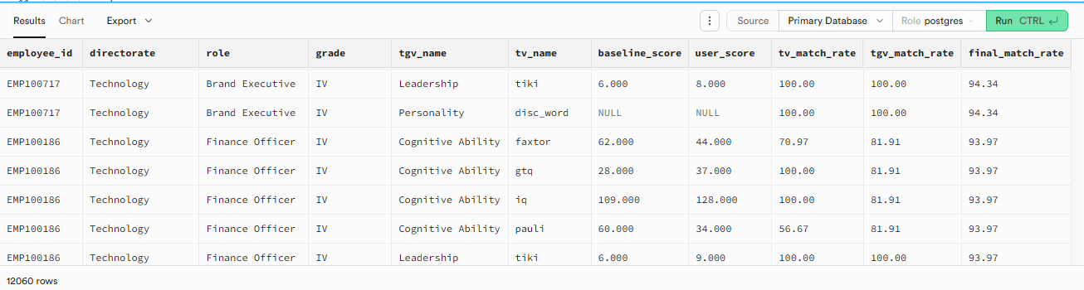

Picture 1. Snapshot of the output table

1. **AI App & Dashboard Overview**

**Link:** <https://talent-match-intel-dd8znettwwxuhhjt3ehuu4.streamlit.app/>

**Inputs**

1. Role name, job level, role purpose
2. Benchmark employee selection (filtered by role)

**AI Component**

1. Uses Groq’s LLM to generate job profiles based on user input
2. Model: llama-3.1-8b-instant
3. Output: Role description, requirements, and key competencies

**Outputs:**

1. final_match_rate: The weighted overall percentage alignment of the employee's profile with the benchmark.
2. tgv_match_rate: The average match percentage within broader categories (Talent Group Variables, e.g., Leadership).
3. tv_match_rate: The match percentage for a single, specific trait (Talent Variable, e.g., IQ).
4. baseline_score: The median score of the high-performer benchmark group for any given trait.
5. user_score: The raw psychometric score of the individual employee.

**Key Visualizations:**

1. Competency Radar Chart: Displays the tgv_match_rates for the top-ranked candidate. This provides an immediate, graphical view of the candidate’s profile shape against the benchmark across all major competency areas (e.g., Cognitive, Leadership).
2. Summary Metric Cards: Prominently features essential aggregate numbers at the top of the results screen: the Top Candidate's Name and Match Rate, the Median Match Rate of the entire pool, and the Total Candidates Analyzed.

**Insight Narratives:**

1. Candidate Ranking Table: A sortable table that lists all analyzed employees, primarily ranked by final_match_rate (descending). This offers managers the complete talent pipeline for review.
2. Key Findings Summary: A dedicated section that highlights the Top 3 Candidates with their names and final match scores, providing a concise, written summary of the highest-potential talent.

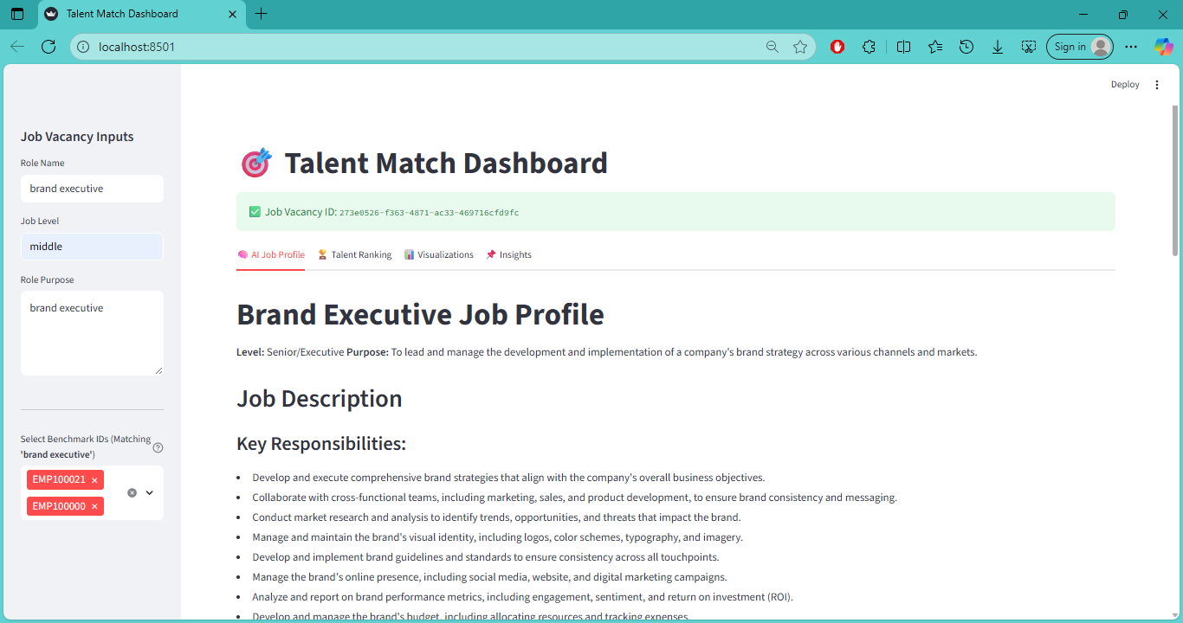

Picture 2. Snapshot of the Talent Match Dasboard – AI Job Profile

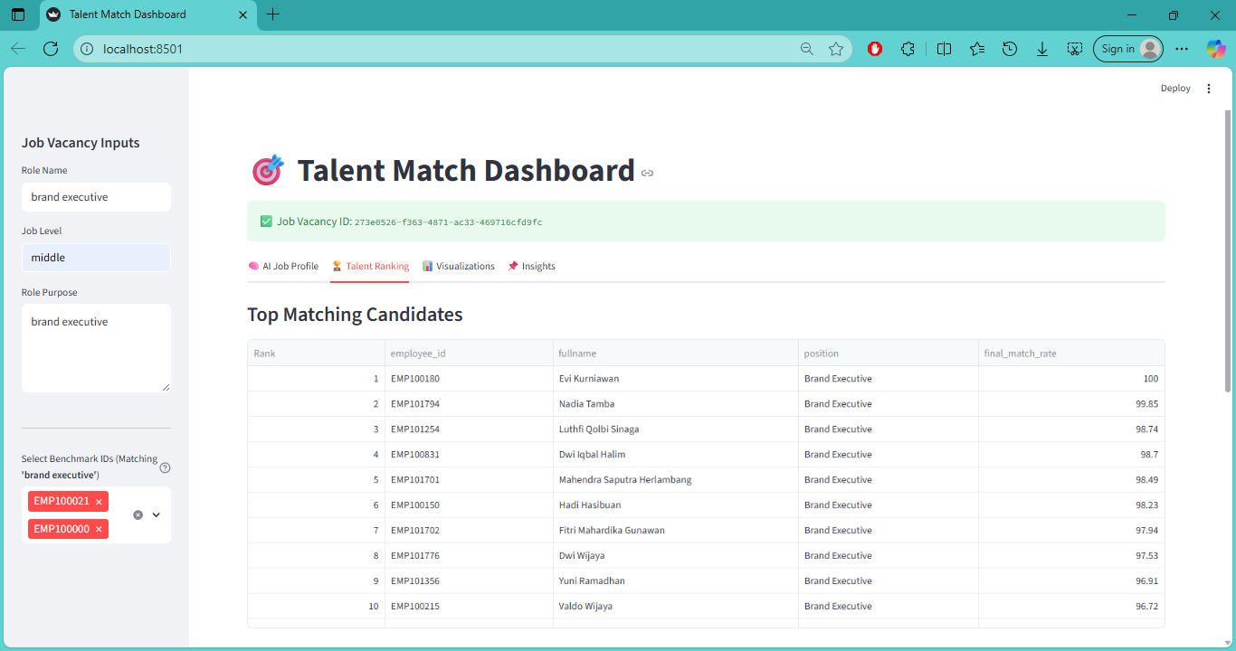

Picture 3. Snapshot of the Talent Match Dasboard – Talent Ranking

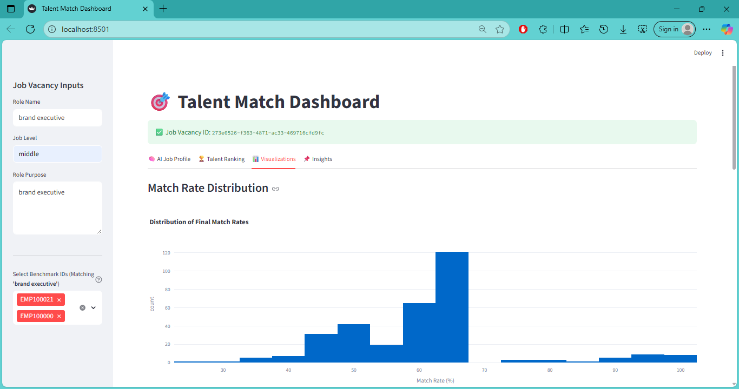

Picture 4. Snapshot of the Talent Match Dasboard – Visualization

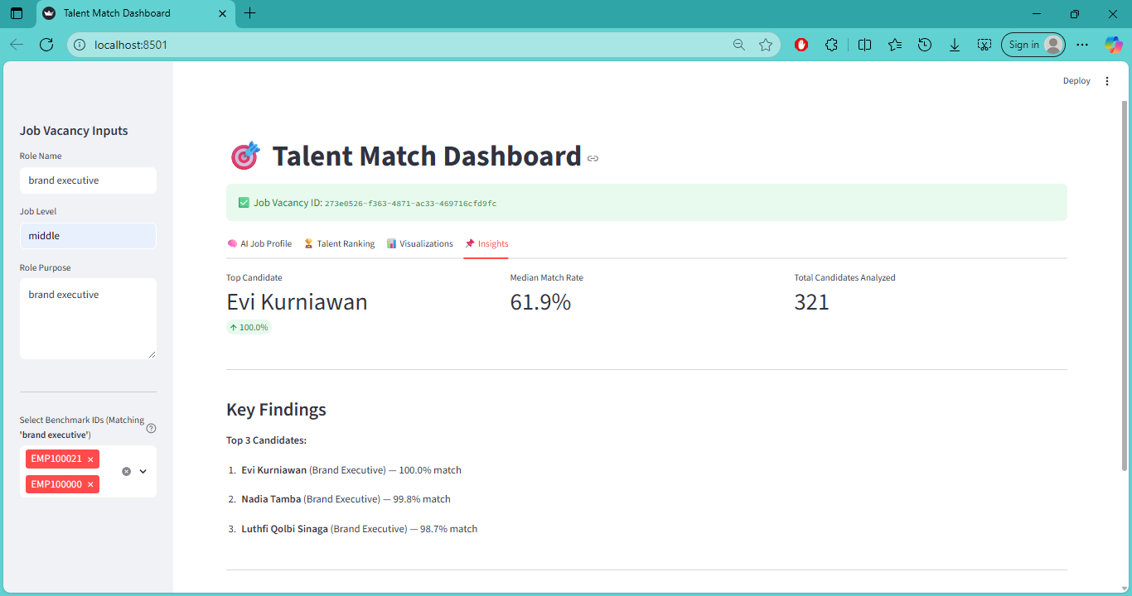

Picture 5. Snapshot of the Talent Match Dasboard – Visualization

1. **Conclusion**

The project successfully delivered a working prototype for data-driven talent benchmarking, translating advanced analytical findings into an actionable dashboard interface.

**Reflections**

1. Objective Benchmark: Successfully shifted the standard from subjective manual selection to a statistically sound high-performer profile by automatically identifying employees with a rating = 5 via the performance_yearly data table.
2. Integration Success: Achieved stable integration across three key technologies: PostgreSQL/Supabase (SQL logic), a Generative AI model (LLM/Groq for job profiles), and the Streamlit front-end.
3. Operationalizing Strategy: The final match score directly reflects the core finding of the project, focusing the analysis on the 75% Behavioral Mindset driver of success.

**Challenges**

1. Data Structure Accuracy: A critical challenge was the necessary adjustment to join the employees and performance_yearly tables to correctly access the rating and define the benchmark group, proving initial assumptions about data location can be a technical dependency.
2. LLM Output Consistency: Generating structured, reliable AI job profiles required significant prompt engineering for the Groq LLM to consistently deliver the required format (description, requirements, competencies) with minimal user input.
3. Performance Optimization: Maintaining speed and responsiveness in the dashboard was challenging, as the SQL engine runs complex aggregations (medians, modes, joins) across the entire employee population before the results can be filtered and displayed.

**Ideas for Improvement**

1. Implement Full Success Formula Weights: Modify the SQL logic to explicitly incorporate the 75% / 15% / 10% weightings into the final match calculation, ensuring the algorithm precisely aligns with the strategic success formula.
2. LLM-Powered Gap Analysis: Integrate the LLM to consume the score gaps (baseline_score vs. user_score) and generate personalized, narrative development suggestions for candidates, focusing on the weakest TGV categories.
3. "What-If" Benchmarking: Introduce controls on the dashboard to allow users to dynamically change the benchmark group (e.g., benchmark against "All Grade 7s" or "Top 10% of the Marketing Directorate") for comparative analysis.
4. Predictive Analytics: Evolve the tool from descriptive benchmarking to a predictive system capable of estimating an employee's future Rating 5 Potential using a trained machine learning model.